Jenkins installed and running.Created dir demo and a script file test.sh inside the dir
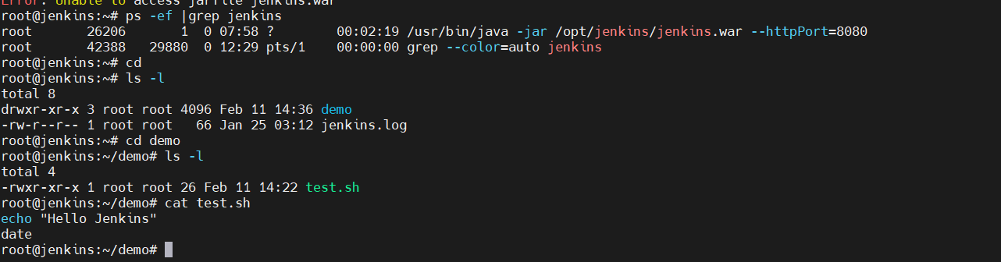
Initialized Git locally and pushed code(test.sh) to github
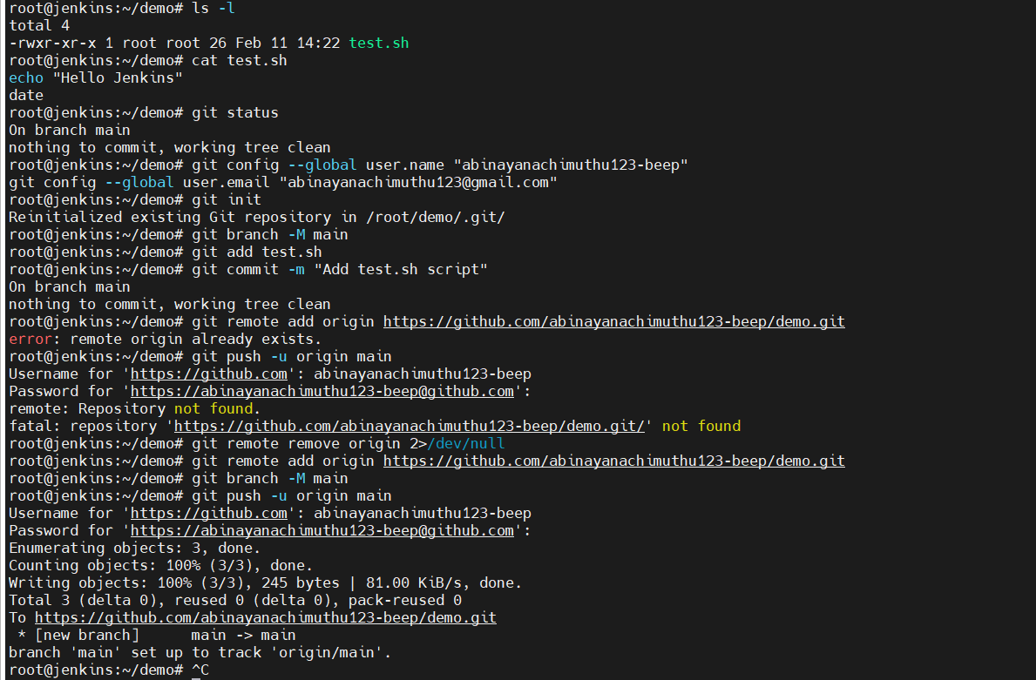
Jenkinsfile -jenkins Instruction file and pushed into Github
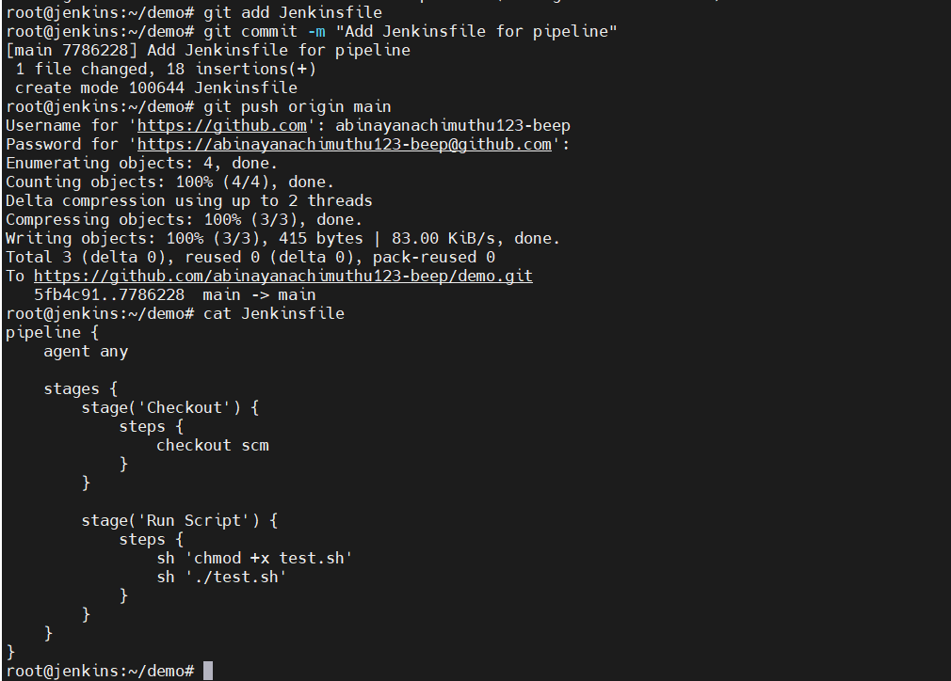
Shell script which Simulates a build step and Simulates a build
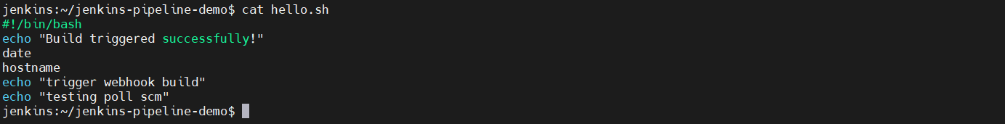
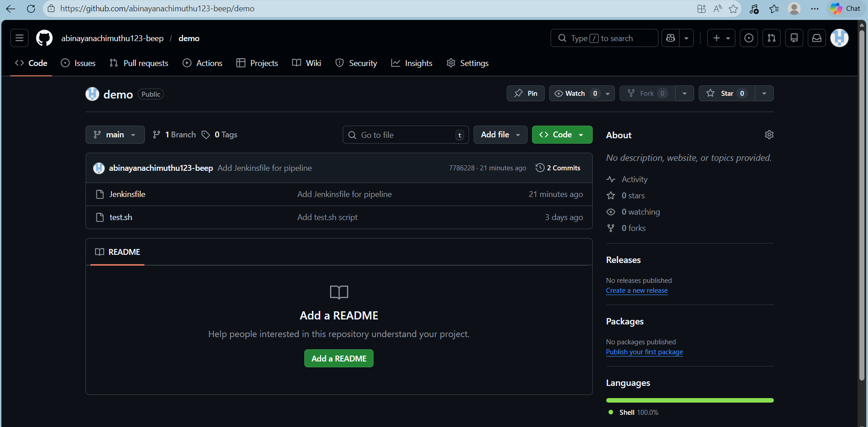
Pipeline has been build
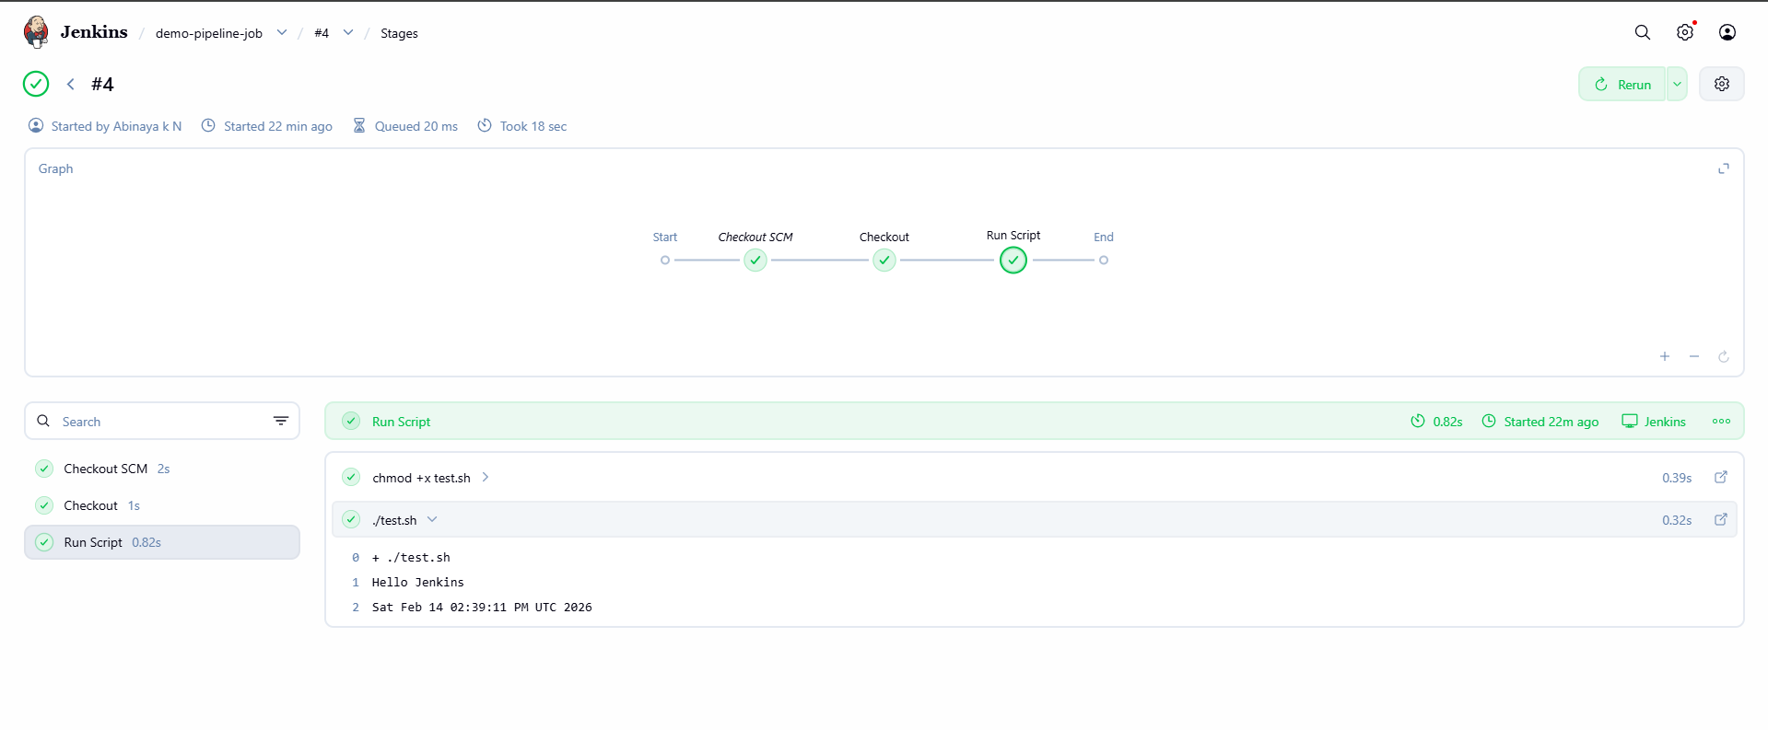
Email Notification:
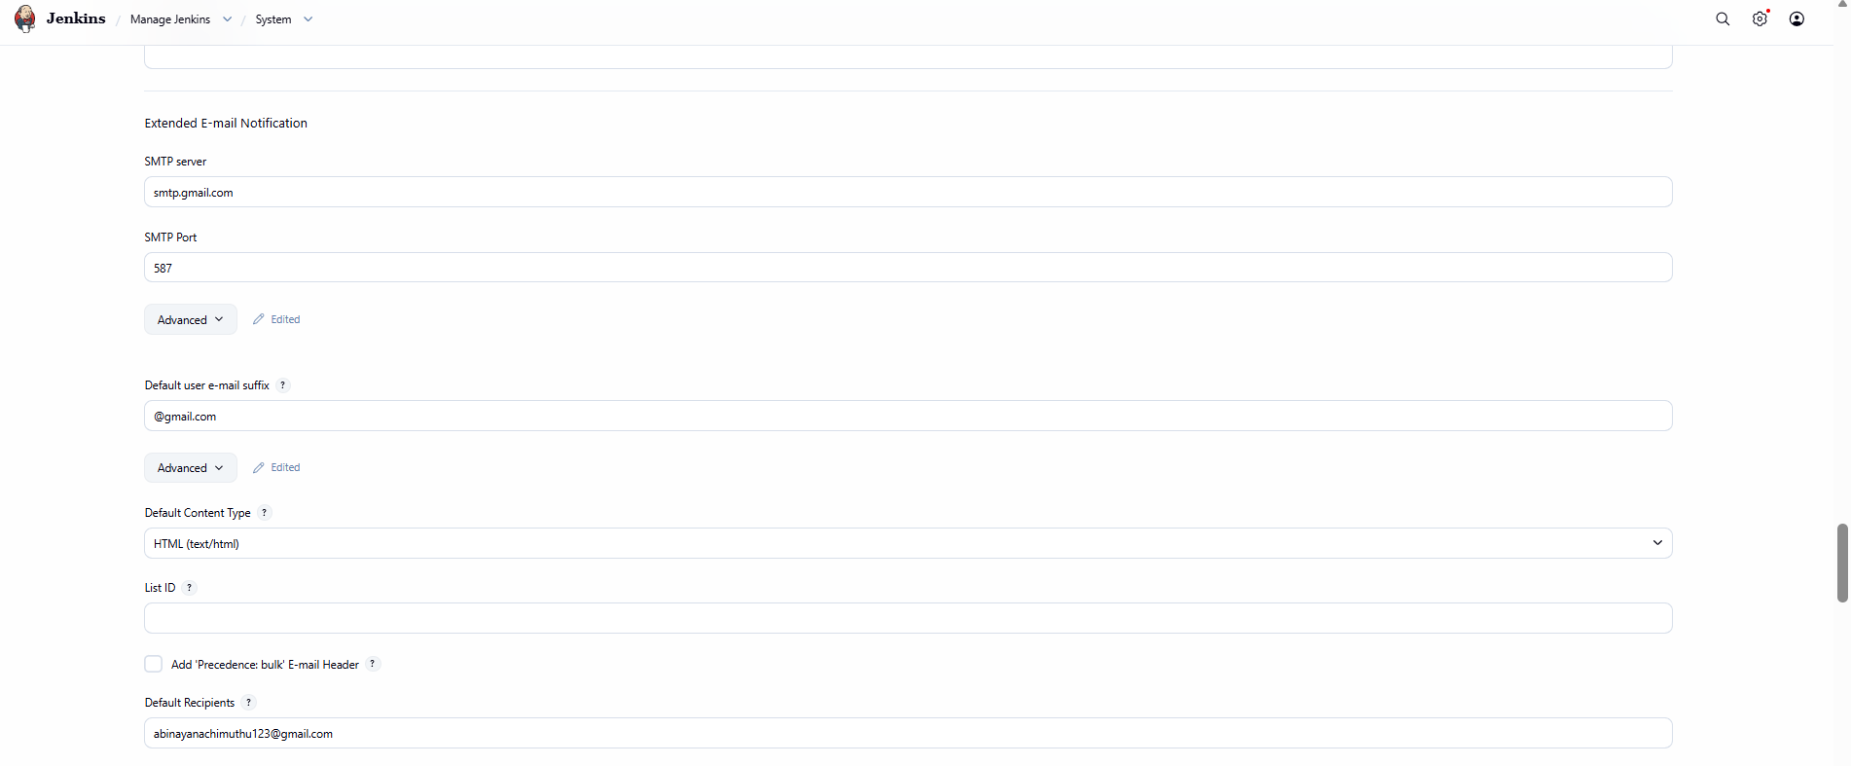
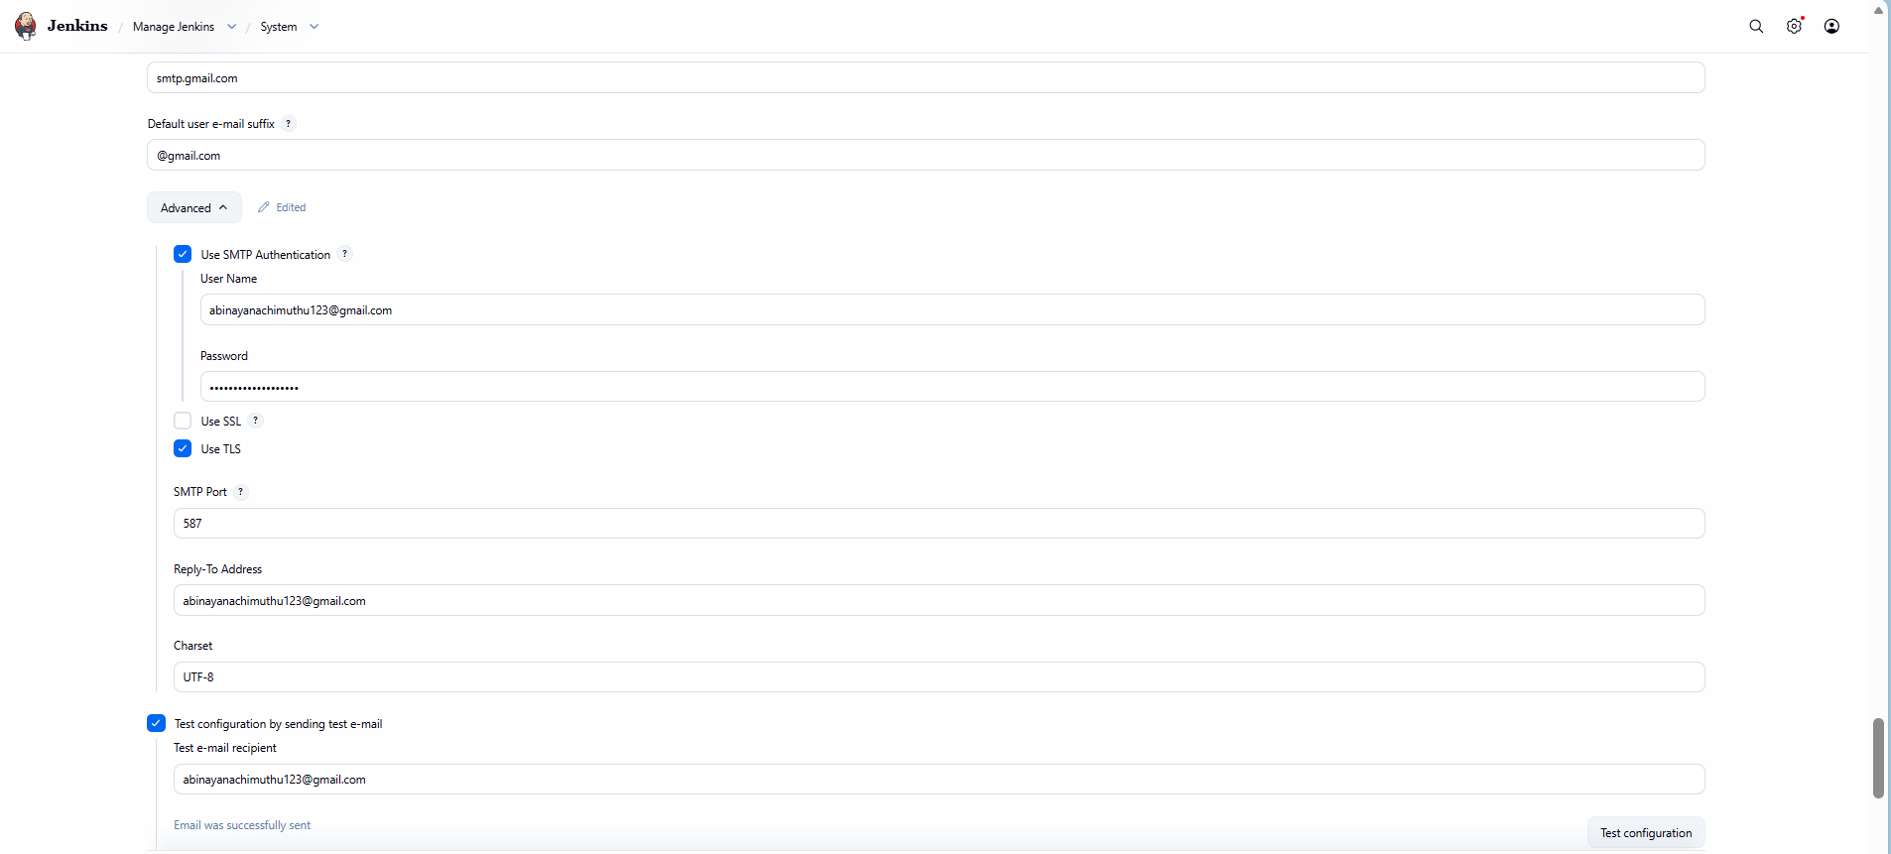
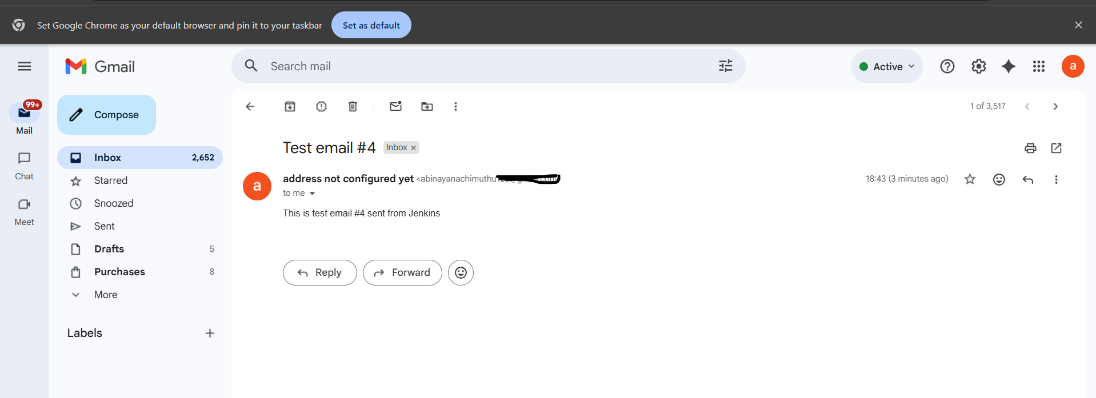
email notification when pipeline success
